Guidance for STAFF on the use of Personal Protective Equipment in education settings in the context of coronavirus (covid-19)
This document provides guidance on the required precautions and correct use of Personal Protective Equipment (PPE) across education settings, including mainstream and specialist schools, in the context of the coronavirus (COVID-19) pandemic.
This document should be read together with Health advice for all Victorian schools and
Health and safety advice for early childhood education and care services in the context of coronavirus (COVID-19)
This document contains the following sections:
- General face mask requirements for Victoria
- Indications for use of PPE when caring for individuals who are not displaying symptoms of COVID-19
- Indications for use of PPE when caring for individuals who are displaying symptoms of COVID-19
- Types of PPE
- Putting on and removing PPE
The Department of Education and Training has developed a video, Guidance for the use of PPE in education settings, which illustrates how to safely use PPE.
A video developed the Royal Australian College of General Practitioners, How to fit a P2/N95 mask, is a useful resource for undertaking a fit check for a P2/N95 respirator.

SECTION A: General face mask requirements for Victoria
As per the Term 4 School’s operations guide:
- All school-based staff must wear face masks at school, and when travelling to and from school.
- A face mask that covers the nose and mouth is now the only permitted type of face covering. Face shields, scarves or bandanas on their own do not meet these requirements.
- Teachers and education support staff are not required to wear face masks while teaching, but those who wish to do so, can. Teachers must wear face masks in other areas of the school when not teaching (for example, in the staffroom, on yard duty and when providing first aid or taking temperatures), and when travelling to and from school.
- Health, wellbeing and inclusion staff are required to wear face masks, unless an exemption applies, including the need for ‘clear enunciation or visibility of their mouth’ (for example, when undertaking a speech therapy intervention or working with individuals who are deaf or hard of hearing).
For further information regarding general face mask requirements in Victoria, see the Department of Health and Human Services website advice about face coverings.

SECTION B: Indications for use of PPE when caring for individuals who are not displaying symptoms of COVID-19
In addition to the mandatory use of face masks in Victoria (see Section A), the Department of Health and Human Services (DHHS) does not otherwise recommend the use of additional PPE, beyond what would be typically indicated for an episode of care, for individuals who are not displaying symptoms of COVID-19.
Table 1 sets out PPE requirements in the context of COVID-19 when providing care to individuals who are not displaying symptoms of COVID-19.
Table 1 does not specify PPE indicated for a specific episode of care, e.g. gloves when dealing with blood as part of first aid. Please see local infection control policies and procedures for further information regarding usual PPE indications.

Table 1: Recommended additional PPE to support the provision of care for individuals who are not displaying symptoms of COVID-19
 | Hand hygiene | 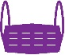  Single use, surgical mask | N95/P2 respirator | 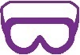  Eye protection | 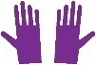  Gloves | 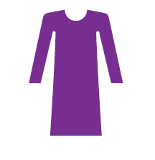  Disposable fluid repellent gown
Staff member providing close contact supervision or care (cannot maintain physical distance of >1.5m) | YES | NO  Unless indicated by the episode of care | NO | NO  Unless indicated by the episode of care | NO  Unless indicated by the episode of care | NO  Unless indicated by the episode of care
When two or more staff members need to come into close contact with each other (less than 1.5m) to perform an episode of care. | YES | NO  Unless indicated by the episode of care | NO | NO  Unless indicated by the episode of care | NO  Unless indicated by the episode of care | NO  Unless indicated by the episode of care
When undertaking a routine aerosol generating procedure (AGP). | YES | NO⁵ | NO | NO | NO | NO
When a child or young person is displaying aerosol generating behaviours (i.e. screaming, shouting, crying out and vomiting). | YES | NO⁵ | NO | NO | NO | NO

SECTION C: Indications for use of PPE for individuals who are displaying symptoms of COVID-19
Where an individual is displaying symptoms of COVID-19 the use of additional PPE may be appropriate. Recommendations for the appropriate use of PPE are dependent on:
- the length of supervision
- the level of care required
- whether a child or young person can safely be placed in a separate room/area temporarily
- whether a child or young person can safely and practically tolerate a mask.
Table 2 sets out recommended PPE to be used when individuals are displaying symptoms of COVID-19. Table 2 does not specify PPE indicated for a specific episode of care, e.g. gloves when dealing with blood as part of first aid. Please see local infection control policies and procedures for further information regarding usual PPE indications.
PPE requirements set out below would also be applicable in the rare event that a student or staff member is informed during the course of the school day that they are a close contact of a confirmed case, while they await collection and return home to commence quarantine.

Table 2: Recommended additional PPE to support the provision of care for individuals who are displaying symptoms of COVID-19
 | Hand hygiene | Single use, surgical mask | N95/P2 respirator | Eye protection | Gloves | Disposable fluid repellent gown
For the individual who is displaying symptoms of COVID-19 | YES | YES | NO | NO | NO | NO
For a staff member providing non-contact supervision while a child or young person awaits collection (can maintain physical distance of >1.5m). | YES | YES | NO | NO | NO | NO
In addition to PPE indicated by the episode of care:  A staff member providing close contact supervision or care (cannot maintain physical distance of >1.5m) while a child or young person awaits collection. Including care of children with complex health needs. | YES | YES | NO | YES | YES | YES
When undertaking an essential aerosol generating procedure (AGP) while a child or young person awaits collection. | YES | NO | YES  (+/- face shield) | YES | YES | YES
When a child or young person is displaying aerosol generating behaviours (i.e. screaming, shouting, crying out and vomiting). | YES | NO | YES  (+/- face shield) | YES | YES | YES

SECTION D: Types of PPE

Hand hygiene
Effective hand hygiene is one of the most important strategies in preventing infection.
Hands should be washed with soap and water if they are visibly soiled, otherwise alcohol-based hand rub with at least 60 percent alcohol should be used.
Gloves are NOT a substitute for hand hygiene.
Detailed instructions on hand washing are available from DHHS - Wash your hands regularly - poster

Gloves
Gloves are recommended when there is direct hand contact with blood or body substances, mucous membranes or wounds or if there is a chance that touching could transmit infection.
Hand hygiene should be performed prior to putting on gloves and after gloves are removed. Alcohol-based hand rub should NEVER be applied to gloves.
Gloves must be changed between individuals and after every episode of individual care. Individuals who are sensitive to latex should ensure that they wear non-latex gloves.

Fluid repellent gown
Fluid repellent gowns are worn to protect body areas and prevent contamination of clothing with blood, body substances, and other potentially infectious material.
Gowns should be removed in a manner that prevents contamination of clothing or skin. The outer, ‘contaminated’, side of the gown is turned inward and rolled into a bundle, and then discarded appropriately (see Putting on and removing PPE).
Please note – gowns are recommended and preferred for use where available in education settings instead of coveralls.

Eye protection
For protection against sprays, splashes and respiratory droplets, safety glasses (with side protection), goggles or a face shield should be used.
Personal eyeglasses and contact lenses are not considered adequate eye protection.
If reusable, protective eyewear should be cleaned and disinfected according to the manufacturer’s instructions, generally with detergent solution, dried then wiped over with a disinfectant (for example, > 70% alcohol) and be completely dry before being stored.
Disposable protective eyewear must be discarded after removal.

Face masks

Single use face masks
Single use face masks (commonly called surgical masks) are used as part of standard precautions to keep splashes or sprays from reaching the mouth and nose of the person wearing them. Surgical masks are made with a non-woven meltblown polypropylene layer and available in various levels of protection.
A surgical mask can be worn for up to 4 hours. A surgical mask must be changed following episodes of care as required, and if the mask becomes damaged, soiled, wet or damp at any time it must be changed. As these are single use masks they can’t be washed and used again.
DHHS advise the following for correct use of a surgical mask:
- Perform hand hygiene before putting on a mask.
- Check for defects in the mask, such as tears or broken loops.
- Position the coloured side of the mask outward.
- If present, make sure the metallic strip is at the top of the mask and positioned against the bridge of your nose.
- If the mask has:
- Ear loops: Hold the mask by both ear loops and place one loop over each ear.
- Ties: Hold the mask by the upper strings. Tie the upper strings in a secure bow near the crown of your head. Tie the bottom strings securely in a bow near the nape of your neck.
- Dual elastic bands: Pull the bottom band over your head and position it against the nape of your neck. Pull the top band over your head and position it against the crown of your head
- Mould the bendable metallic upper strip to the shape of your nose by pinching and pressing down on it with your fingers.
- Pull the bottom of the mask over your mouth and underneath the chin.
- Be sure the mask fits snugly.
- Don’t touch the mask once in position.
Surgical masks should not be used in situations where an individual is unable to safely or practically tolerate a mask. For example:
- A child or young person with an underlying health condition, including but not limited to respiratory conditions.
- A child or young person who is resistant to wearing a mask (either due to age, developmental or behavioural challenges). Children aged under two year should never wear a mask. In this situation it is better for the staff member to wear a mask (where available) while maintaining distance and good hand hygiene.
Please note - Some settings may have received a supply of P1 masks in addition to surgical masks. Figure 1 illustrates the difference in appearance these two types of masks. Wherever possible a surgical mask should be used.
When a surgical mask is unavailable, a P1 mask can be used for a short period as a replacement for a single-use face mask. However, as P1 masks have not been designed for fluid resistance they should be disposed of immediately if they are splattered on (for example, if a child/young person were to cough during the provision of direct care).
P1 masks should not be worn by individuals with underlying respiratory conditions or used for children.

Figure 1: Appearance of surgical masks and P1 masks
Surgical mask  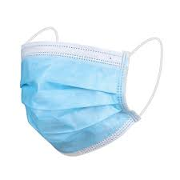 | P1 mask  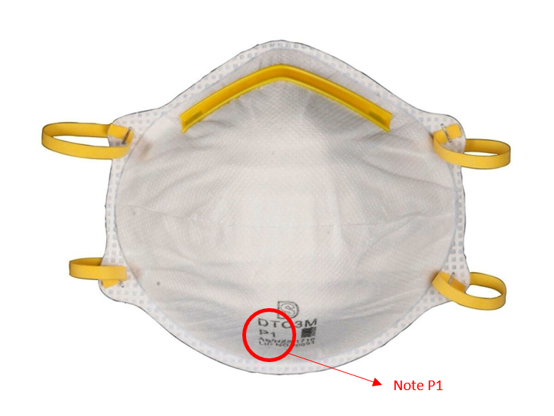

P2/N95 (filtering facepiece) respirators
Respirators prevent the inhalation of small particles that may contain infectious agents transmitted via the airborne route. P2/N95 respirators are only recommended for use by trained staff when individuals are displaying symptoms of COVID-19 and:
- staff are required to perform aerosol generating procedures (AGPs)
- individuals are displaying aerosol generating behaviours (i.e. screaming, shouting, crying out and vomiting).
Check specifications to ensure fluid resistance. Where a mask is not fluid resistant, the respirator can be used in combination with a face shield (refer to section on face shields).
Respirators that have not been designed for fluid resistance should be disposed of immediately if they are splattered on.
Please note - P2/N95 respirators for use in education settings must not have a one-way valve (see Figure 2). These respirators do not provide appropriate protection.

Fit checking
Fit checking is the process of ensuring a P2/N95 respirator/mask seals properly once it has been applied. It makes sure the respirator is sealed over the bridge of the nose and mouth and that there are no gaps between the respirator and face.
You must read the manufacturer’s instructions for fit checking the respirator you are using and practise doing it properly before using a P2/N95 respirator.
You must perform a fit check every time you use a P2/N95 respirator, even if you have fit checked the same kind before.
You should not provide care or support until your respirator fits properly.
If you have facial hair (including 1–2 day stubble), please be aware that an adequate seal cannot be achieved between the P2/N95 respirator and your face. You will need to shave.
You must read the manufacturer’s instructions for fit checking the respirator you are using and practise doing it properly before using a P2/N95 respirator with a student.
Fitting the respirator starts the same as putting on a surgical mask. The difference is that you need to fit check your respirator with a colleague (buddy).
The procedure for fit checking is:
- While breathing in and out place your hands around the top and sides of the respirator to check for leaks. You should not feel any air coming out and the respirator should be drawn in when inhaling
- Cover the respirator with both hands and inhale sharply
- If the respirator is not drawn in towards the face, or air leaks around the face seal then there is not a good seal. This must be fixed
- Readjust the respirator if necessary and repeat the process. You may have to do this several times
- If it still does not work, your buddy should check that you have the respirator on correctly, that the ties are not crossed or that there are no defects
- If it still does not seal after your buddy checks it, change the respirator for one of a different size or shape.
A video developed the Royal Australian College of General Practitioners, How to fit a P2/N95 mask, is a useful resource for undertaking a fit check for a P2/N95 respirator.

Figure 2: Correct and incorrect P2/N95 respirators
Correct mask – no valve  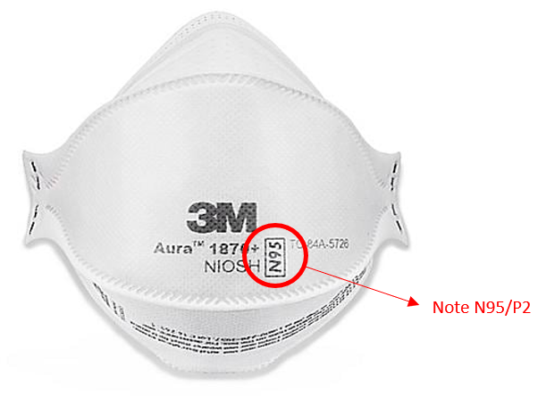 | Incorrect mask – with valve  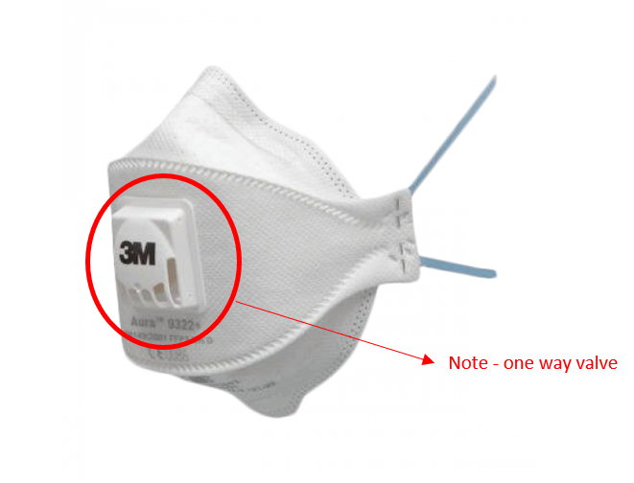

Face shields
Face shields are primarily used for eye protection, in combination with a face mask or respirator.
As face shields do not cover the nose and mouth, they no longer meet Victorian requirements as an alternative to a face mask, providing a lower level of protection for both the user and those around them. There may, however, be limited situations where a face shield is used where it is not practical or safe for an individual to wear a face mask.
Face shields may be considered for use in education settings in the following circumstances:
- As a substitution for eye protection, where goggles or glasses are unavailable.
- In place of a surgical mask when providing routine care and support to a well child or young person whose care may be impacted by not being able to see staff member’s facial expressions. This should only be in exceptional circumstances.
- In combination with a P2/N95 respirator when performing an essential aerosol generating procedure on a child or young person displaying symptoms of COVID-19. The face shield in this situation protects a non-fluid resistant respirator from droplets and sprays, as well as providing eye protection.
- In combination with a P2/N95 respirator when a child or young person is displaying symptoms of COVID-19 and aerosol generating behaviours. The face shield in this situation protects a non-fluid resistant respirator from droplets and sprays, as well as providing eye protection.
A face shield should never be used in place of a face mask when providing supervision or to care to someone displaying symptoms of COVID-19.
Face shields should be properly designed to cover the sides of the face and below the chin. Reusable face shields should be cleaned and disinfected after each use with a detergent/disinfectant wipe. Disposable face shields should only be worn for single use.

SECTION E: Putting on and removing PPE

General principles
It is important that staff are mindful of their own health and wellbeing when using PPE.
Staff should remember to hydrate themselves prior to putting or and after removing PPE.
Staff must practice hand hygiene and avoid touching their faces.

Sequence for putting on (donning) and taking off (doffing) PPE

Donning (putting on)
The sequence for donning PPE is as follows:
- Hand hygiene
- Gown
- Mask
- Protective eyewear (or face shield where applicable)
- Gloves

Doffing (taking off) PPE
PPE should be removed in an order that minimises the potential for cross contamination.
The sequence for doffing PPE is as follows:
- Gown and gloves
- Hand hygiene
- Protective eyewear (or face shield where applicable)
- Mask
- Hand hygiene
Detailed instructions are available from DHHS - How to put on (don) and take off (doff) your PPE
Also see DET video, Guidance for the use of PPE in education settings

Disposing of PPE
PPE should be disposed of in the following manner:
- Put into a plastic bag and tied up or sealed.
- Placed into the general waste
- PPE worn during the provision of care for individuals who are displaying symptoms of COVID-19 should be disposed of into secure bin or a lid with a bin.

These are a specific type of PPE, as opposed to general use face masks, reusable or otherwise, that are mandatory in Victoria.
Includes where there is deliberate spitting/coughing on staff
Includes providing care that may involve exposure to blood, body fluids, touching mucous membranes or non-intact skin
General face masks requirements still apply. See Section A.
General face masks requirements still apply. See Section A.
Includes high flow nasal oxygen, suctioning etc.
These are a specific type of PPE, as opposed to general use face masks, reusable or otherwise, that are mandatory in Victoria.
See ‘Face masks’ section of this guidance to guide appropriate use of masks for unwell staff, children and young people. Never to be used on children under two years or children unable to tolerate a mask.
Includes where there is deliberate spitting/coughing on staff
Includes providing care that may involve exposure to blood, body fluids, touching mucous membranes or non-intact skin
Where a child/young person is displaying symptoms of COVID-19, only essential AGPs that support emergency care should be undertaken. All other AGPs should be postponed until the child or young person is collected by their parent/carer.
Where a respirator is not fluid resistant, it can be used in combination with a face shield
Where a respirator is not fluid resistant, it can be used in combination with a face shield
Australian Guidelines for the Prevention and Control of Infection in Healthcare (2019)
Australian Guidelines for the Prevention and Control of Infection in Healthcare (2019)
DHHS. Coronavirus disease 2019 (COVID-19) Case and contact management guidelines for health services and general practitioners 14 April 2020 Version 18
Australian Guidelines for the Prevention and Control of Infection in Healthcare (2019)
Australian Guidelines for the Prevention and Control of Infection in Healthcare (2019)
Australian Guidelines for the Prevention and Control of Infection in Healthcare (2019)
Australian Guidelines for the Prevention and Control of Infection in Healthcare (2019)
DHHS. Coronavirus disease 2019 (COVID-19) Case and contact management guidelines for health services and general practitioners 14 April 2020 Version 18

