 | STANDARDS / PRODUCT | CONTENT |  | SKILLS
 | PROCESS | WHAT DOES IT LOOK LIKE? |  | WHAT DOES IT SOUND LIKE? | WHAT DOES IT FEEL LIKE?
 | LEARNING TARGETS  How would we make these lines match up? |  | LEARNING STRATEGIES
 | PURPOSE  - DRILL & PRACTICE  - SCRIMMAGE / REHEARSAL  - AUTHENTIC / RELEVANT  - REFLECTION |  | TASK DESIGN
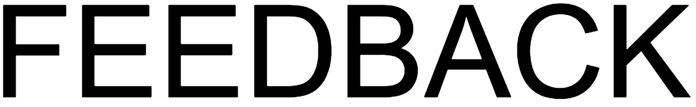 | COMMUNICATION WITH LEARNER | - SELF-NAVIGATE TOOL  - RUBRIC  - CHECKLIST  - REFLECTION  - PORTFOLIO  - INTERACTIVE NOTEBOOK  - OTHER

